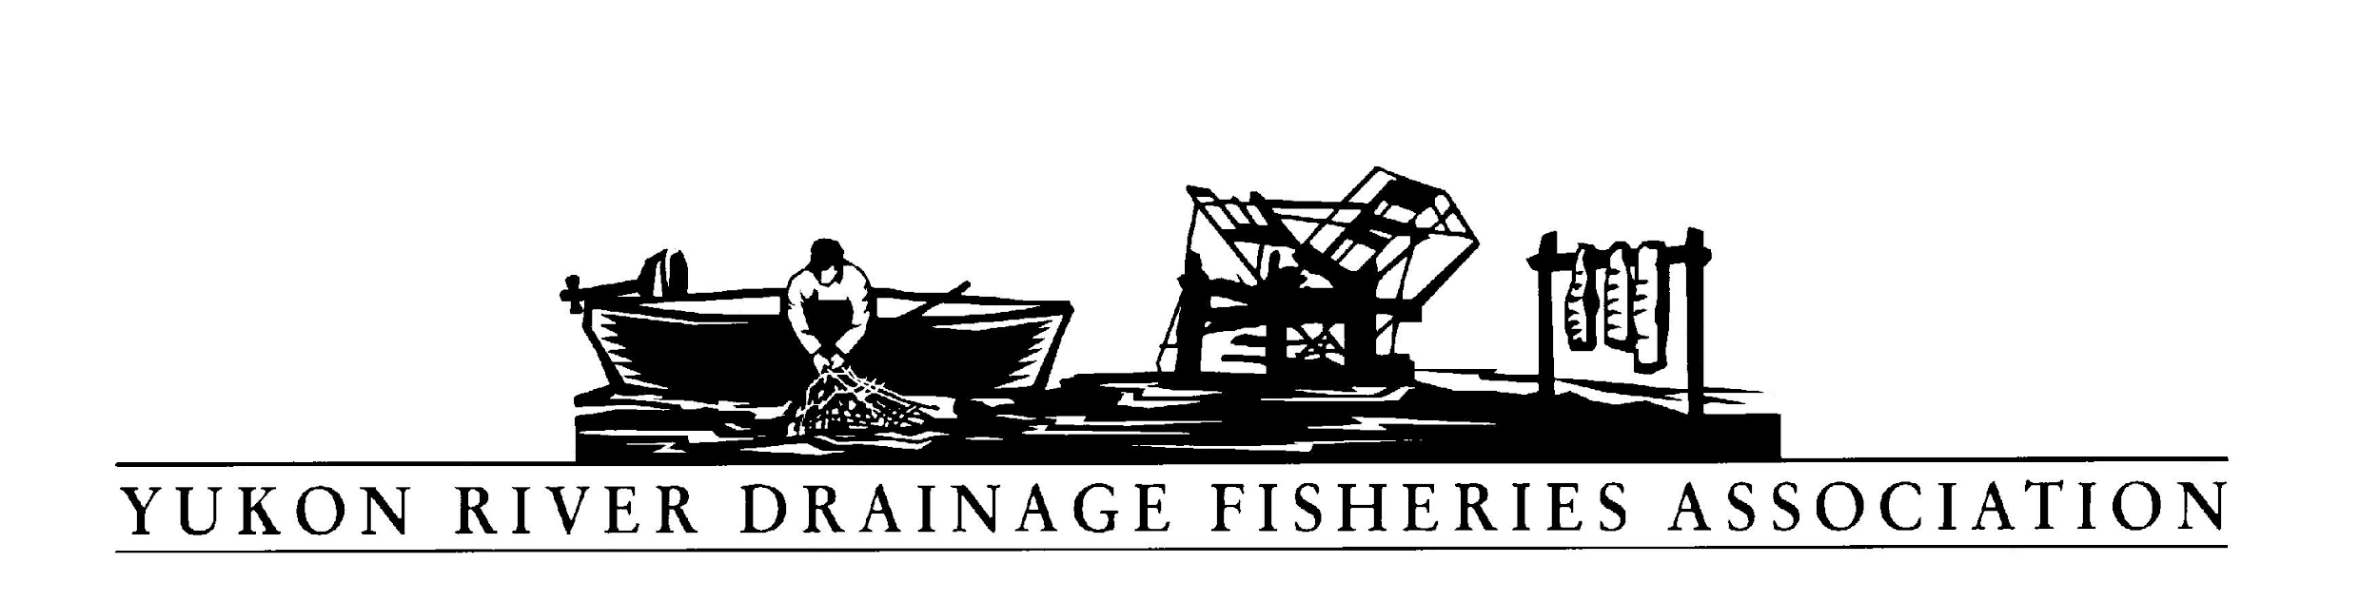PO Box 2898 Palmer, AK 99645
Tel: 907-272-3141 Toll free: 877-999-8566
Fax: 907-272-3142 E-mail: wayne@yukonsalmon.org
Executive Director Position Description
The Executive Director is the key manager of YRDFA. The Executive Director is responsible for overseeing the administration, programs, and strategic plan of the organization. Other key duties include fundraising, communications, and community outreach. The position reports directly to the Board of Directors.
GENERAL RESPONSIBILITIES:
1) Board Governance: Works with board in order to fulfill the organization's mission.
- Responsible for leading YRDFA in a manner that supports and guides the organization’s mission as defined by the Board of Directors.
- Responsible for communicating effectively with the Board and providing, in a timely and accurate manner, all information necessary for the Board to function properly and to make informed decisions.
2) Financial Performance and Viability: Develops resources sufficient to ensure the financial health of the organization.
- Responsible for the fiscal integrity of YRDFA, to include submission to the Board of a proposed annual budget and financial statements, which accurately reflect the financial condition of the organization.
- Responsible for fiscal management that generally anticipates operating within the approved budget, ensures maximum resource utilization, and maintenance of the organization in a positive financial position.
- Responsible for fundraising and developing other resources necessary to support YRDFA’s mission.
3) Organization Mission and Strategy: Works with board and staff to ensure that the mission is fulfilled through programs, strategic planning and community outreach.
- Responsible for implementation of YRDFA’s programs that carry out the organization’s mission.
- Responsible for strategic planning to ensure that YRDFA can successfully fulfill its Mission into the future.
- Responsible for the enhancement of YRDFA’s image by being active and visible in the communities we serve and by working closely with key professional, civic and private organizations.
4) Organization Operations. Oversees and implements appropriate resources to ensure that the operations of the organization are appropriate.
- Responsible effective administration of YRDFA operations.
- Responsible for the hiring and retention of competent, qualified staff.
- Responsible for signing all financial and legal documents made and entered into and on behalf of the organization.
Professional Qualifications:
- Bachelor’s degree
- Transparent and high integrity leadership
- Five or more years senior nonprofit management experience
- Solid, hands-on, budget management skills, including budget preparation, analysis, decision-making and reporting
- Strong organizational abilities including planning, delegating, program development, and task facilitation
- Knowledge of fundraising strategies and donor relations unique to nonprofit sector
- Skills to collaborate with and motivate board members and other volunteers
- Strong written and oral communication skills
- Ability to interface and engage diverse volunteer and donor groups
- Demonstrated ability to oversee and collaborate with staff
- Strong public speaking ability
Job Responsibilities:
- Planning and operation of annual budget.
- Establishing employment and administrative policies and procedures for all functions and for the day-to-day operation of the nonprofit.
- Serving as YRDFA’s primary spokesperson to the organization’s constituents, the media, and the general public.
- Establish and maintain relationships with various organizations throughout the state and utilize those relationships to strategically enhance YRDFA’s Mission.
- Report to and work closely with the Board of Directors to seek their involvement in policy decisions, fundraising, and to increase the overall visibility of YRDFA.
- Supervise, collaborate with organization staff.
- Travel to remote Yukon River communities and urban hubs.
- Strategic planning and implementation.
- Oversee organization Board and committee meetings.
- Oversee marketing and other communications efforts.
- Review and approve contracts for services.
- Other duties as assigned by the Board of Directors.
Work Environment: YRDFA has a virtual office. Staff works at a location of their choice. Communication between staff and board is done via telephone, email, text, and in-person meetings.
Salary: Commensurate with experience and other qualifications. Quality benefits package includes dental and vision insurance, retirement and paid vacation and sick leave.
Email resume, writing sample, and 3 references/contacts by September 30, 2019 to: wayne@yukonsalmon.org.

