P. O. Box 2848, Palmer, Alaska 99645

Tel: 907-272-3141 Fax: 907-272-3142

Resolution: 2019-08

Bureau of Land Management Bering Sea-Western Interior and Central Yukon Resource Management Plans:

Areas of Critical Environmental Concern

WHEREAS, the Yukon River Drainage Fisheries Association (YRDFA) works on behalf of subsistence and commercial fishing families within the Alaskan and Canadian Yukon River drainage who depend on wild salmon for subsistence and commercial fisheries; and

WHEREAS, Chinook salmon provide an essential source of food, income, and culture for the people of the Yukon River in both the United States and Canada; and

WHEREAS, Chinook salmon runs have been low in recent years; and

WHEREAS, potential development activities may threaten the long-term viability of Yukon River wild salmon and other fish stocks by allowing increased pollution and degradation of vital stream habitat; and

WHEREAS, clean water for spawning and rearing is of vital importance for the wild salmon and other fish that provide for subsistence; and

WHEREAS, the people of Yukon River also hunt and trap wild game and harvest and use wild plants and other natural resources as part of their ancient and traditional lifeways; and

WHEREAS, YRDFA is concerned, along with others, that development on BLM managed lands may have adverse effects on Yukon watersheds; and,

WHEREAS, Yukon River villages that have made Areas of Critical Environmental Concern (ACEC) nominations to the Bureau of Land Management (BLM) have done so because these are critically necessary and important fish and wildlife habitat and Customary and Traditional Use Areas;

THEREFORE BE IT RESOLVED that YRDFA will continue its efforts to support villages along the Yukon River that make ACEC nominations because these areas are critical for fish and wildlife habitat and we encourage the Bureau of Land Management (BLM) to protect Traditional Use Areas as ACEC’s, through the Resource Management Planning process and other opportunities.

COPIES of this resolution will be sent to the Bureau of Land Management (BLM), Bearing-Sea & Central Yukon regions; Yukon River Inter-Tribal Watershed Council (YRITWC); U.S. Fish and Wildlife Service (USFWS); Alaska Department of Fish and Game (ADFG); Native (ANSCA) Corporations Calista and Doyon; Tanana Chiefs Conference (TCC); Association of Village Council Presidents (AVCP); Yukon-Kuskokwim Delta, Western Interior and Eastern Interior Federal Subsistence Regional Advisory Councils.

APPROVED unanimously this 24th day of April 2019, by unanimous consent of the Board members and delegates of YRDFA assembled at their Twenty-ninth annual meeting held in Fairbanks, Alaska.

Attest:

Thank you. Yukon River Drainage Fisheries Association Co-Chairs:

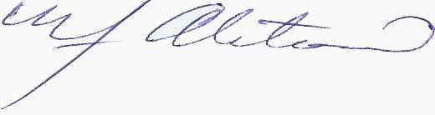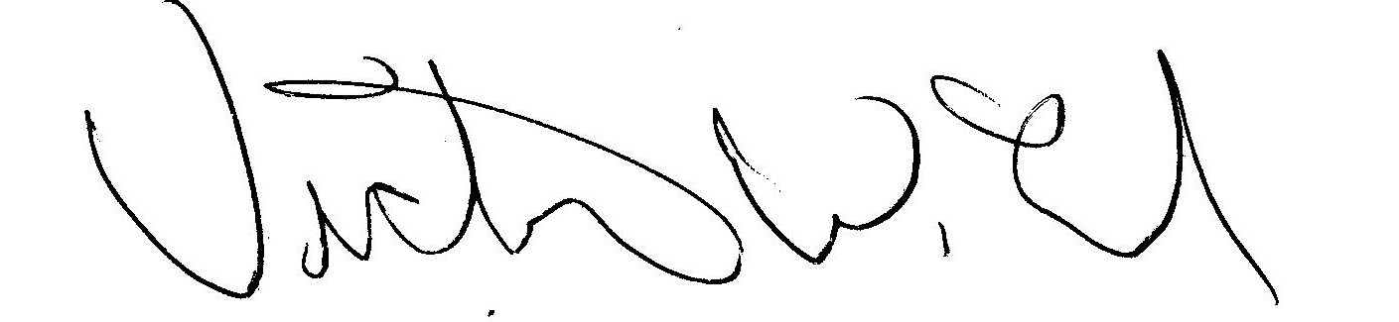
YRDFA Co-Chair/Y-2, Seat 1 YRDFA Co-Chair/Y-6, Seat 2
William Alstrom/Saint Mary’s Victor Lord/Nenana

