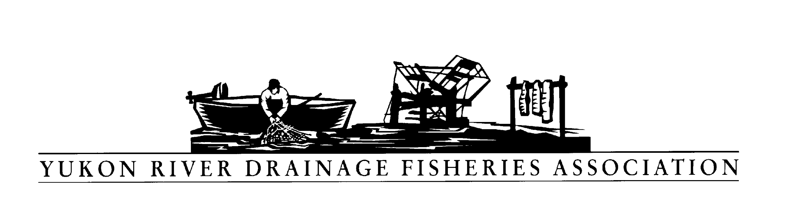
P O Box 2898, Palmer Alaska 99645

Tel: 907-272-3141 Fax: 907-272-3142

2019-07

Concern with Donlin Creek Mine

WHEREAS, the Yukon River Drainage Fisheries Association (YRDFA) works on behalf of subsistence and commercial fishing families within the Alaskan and Canadian Yukon River drainage who depend on wild salmon for subsistence and commercial fisheries; and

WHEREAS, mining activities can contribute to economic development and increased employment in the State of Alaska; and

WHEREAS, mining activities and practices may threaten the long-term viability of Western Alaska wild salmon and other fish stocks by allowing increased pollution and degradation of vital stream habitat; and

WHEREAS, the proposed Donlin mine will operate in the Arctic-Yukon-Kuskokwim Region; and

WHEREAS, clean water for spawning and rearing is of vital importance for the wild salmon and other fish that provide for subsistence; and

WHEREAS, YRDFA is concerned along with others that development of the Donlin mine may have adverse effects to the Kuskokwim and Yukon watersheds; and

WHEREAS, YRDFA is concerned the permitting agencies (federal, state and local) include appropriate terms and conditions in the permits to protect the Native culture and environment from adverse impact due to the mine construction, operations, and subsequent reclamation of the mine and all supporting infrastructure; and

WHEREAS, YRDFA is concerned the governing agencies issuing permits will secure appropriate surety bond(s) to protect against non-compliance of the permit stipulations intended to protect the Native culture and environment from adverse effect; therefore

BE IT RESOLVED that YRDFA expresses its concern that the mine, if permitted, operates with no impacts to the environment and, particularly, no impacts to aquatic life and habitat productivity.

COPIES of this resolution will be sent to Donlin Creek LLC; Alaska Department of Environmental Conservation; Alaska Department of Fish and Game Habitat Division; Yukon River representatives and senators; Yukon Salmon Committee; Yukon River Panel; Department of Fisheries and Oceans, Canada

APPROVED unanimously this 24th day of April by the Directors of YRDFA assembled at their Twenty-ninth Annual Meeting held in Fairbanks, Alaska.

Attest:

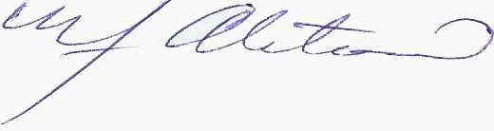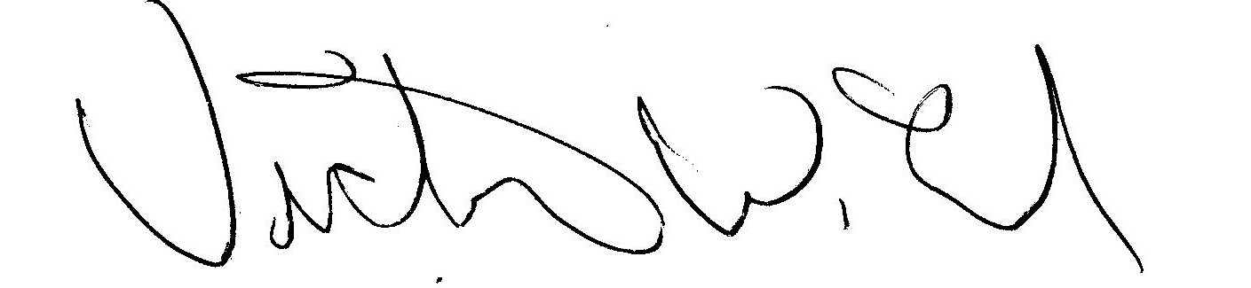
YRDFA Co-Chair/Y-2, Seat 1 YRDFA Co-Chair/Y-6, Seat 2
William Alstrom/Saint Mary’s Victor Lord/Nenana

