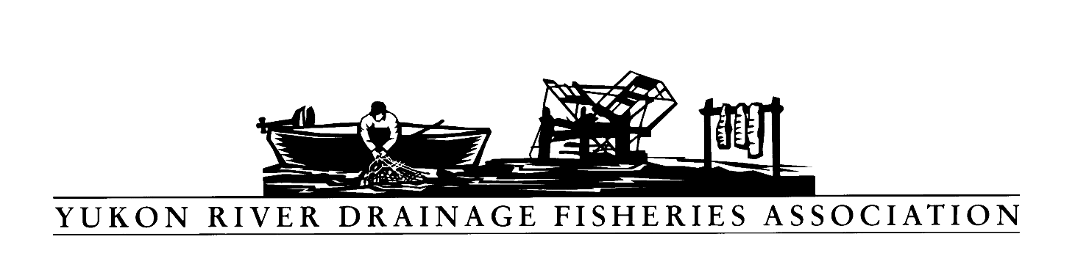
PO Box 2898, Palmer, Alaska 99645
Tel: 907-272-3141 Toll free: 877-999-8566
Fax: 907-272-3142 Email: wayne@yukonsalmon.org

Resolution: 2019-06

Opposition to Large-scale Salmon Hatcheries on the Yukon River

WHEREAS, the Yukon River Drainage Fisheries Association (YRDFA) works on behalf of subsistence and commercial fishing families within the Alaskan and Canadian Yukon River drainage who depend on wild salmon for subsistence and commercial fisheries; and

WHEREAS, Alaska’s hatcheries released over 1.8 billion salmon in 2018; and

WHEREAS total hatchery releases internationally including Alaska into the North Pacific are over 5 billion salmon annually; and

WHEREAS; these salmon intermingle in the North Pacific and compete with wild salmon and other species populations for food; and

WHEREAS; the large number of hatchery fish in the ocean can limit the growth of wild stocks, particularly when ocean conditions are not productive for salmon; and

WHEREAS; the Alaska Board of Fisheries and the Alaska Department of Fish and Game have developed a Joint Protocol on Salmon Enhancement #2002-FB-215 and these increases in hatchery production have been in violation of the Joint Protocol on Salmon Enhancement;

WHEREAS; the 1998 Yukon River Comprehensive Salmon Plan (CSP) strongly opposed any large scale hatcheries on the Yukon River (Guiding Principle #6), preferring that conservative management and restoration in times of low abundance be the management approach rather than enhancement.

THEREFORE, BE IT RESOLVED that YRDFA supports setting specific limits on hatchery production within Alaska and internationally, and specifically opposes large scale hatcheries on the Yukon River. Also that hatcheries follow the Joint Protocol that has been previously established.

COPIES of this resolution will be sent to the Bering Sea Fishermen’s Association, Alaska Department of Fish and Game, the Alaska Board of Fisheries, and Alaska Governor’s Office.

APPROVED unanimously this 24th day of April 2019 by the Board members and delegates of YRDFA assembled at their Twenty-ninth Annual meeting held in Fairbanks, Alaska.

Attest:

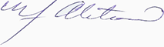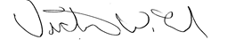

YRDFA Co-Chair/Y-2, Seat 1 YRDFA Co-Chair/Y-6, Seat 2

William Alstrom/Saint Mary’s Victor Lord/Nenana

