P. O. Box 2848, Palmer, Alaska 99645

Tel: 907-272-3141 Fax: 907-272-3142

Resolution: 2019-05

Labeling of Genetically Engineered Salmon

WHEREAS, the Yukon River Drainage Fisheries Association (YRDFA) works on behalf of subsistence and commercial fishing families within the Alaskan and Canadian Yukon River drainage who depend on wild salmon for subsistence and commercial fisheries; and

WHEREAS, Chinook and chum wild salmon provide an essential source of food, income, and culture for the people of the Yukon River; and

WHEREAS, Yukon River wild salmon presently face increasing potential threats from a changing climate; and

WHEREAS, the effects of Genetically Engineered (GE) salmon on our wild salmon resources are unknown and potentially dangerous to wild populations; and

WHEREAS, the health effects of consuming GE salmon are unknown; and

WHEREAS, only accurate labeling laws and oversight can assure consumers the information needed to distinguish between natural wild salmon and GE salmon,

THEREFORE BE IT RESOLVED that YRDFA wants all genetically engineered salmon to be labeled so to distinguish it from wild salmon in the marketplace.

COPIES of this resolution will be sent to US Senator Lisa Murkowski; US Senator Dan Sullivan; US Representative Don Young; Alaska Department of Fish and Game (ADFG); Yukon River Panel YRP); U.S. Fish and Wildlife Service (USFWS); Yukon Delta Fisherman’s Development Association (YDFDA); Bering Sea Fishermen’s Association (BSFA); Association of Village Council Presidents (AVCP); Tanana Chiefs Conference (TCC); Yukon-Kuskokwim Delta, Western Interior and Eastern Interior Federal Subsistence Regional Advisory Councils.

APPROVED unanimously this 24th day of April 2019, by unanimous consent of the Board members and delegates of YRDFA assembled at their 29th annual meeting held in Fairbanks, Alaska.

Attest:

Thank you. Yukon River Drainage Fisheries Association Co-Chairs:

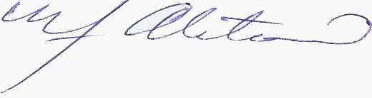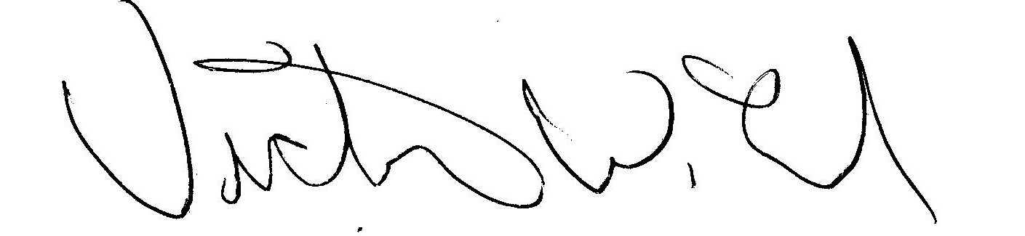
YRDFA Co-Chair/Y-2, Seat 1 YRDFA Co-Chair/Y-6, Seat 2
William Alstrom/Saint Mary’s Victor Lord/Nenana

