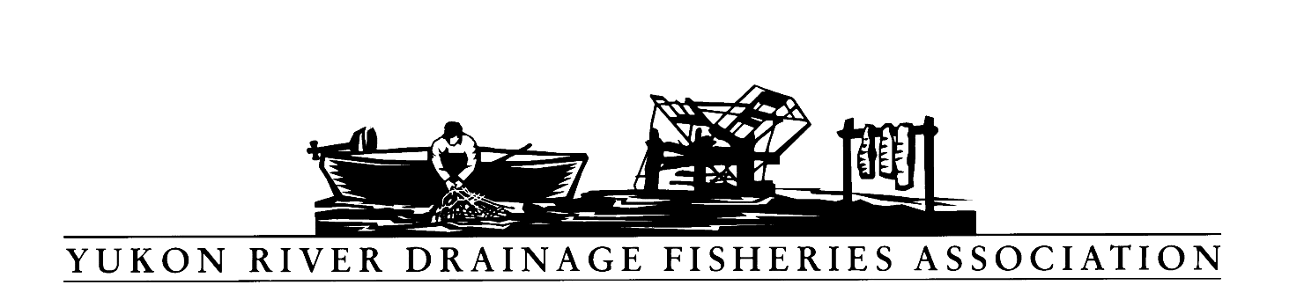
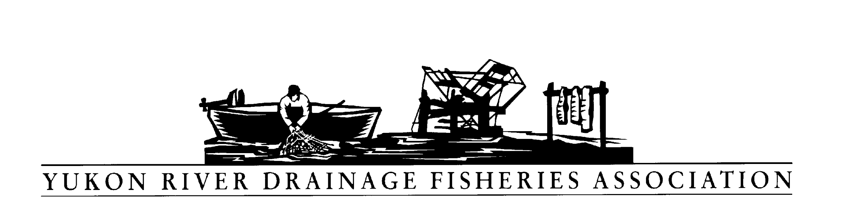
PO Box 2898, Palmer, Alaska 99645
Tel: 907-272-3141 Toll free: 877-999-8566
Fax: 907-272-3142 E-mail: wayne@yukonsalmon.org

Resolution: 2019-04

Transboundary Mining in the Yukon River Watershed

Joining the SE transboundary coalition

WHEREAS, the Yukon River Drainage Fisheries Association (YRDFA) works on behalf of subsistence and commercial fishing families within the Alaskan and Canadian Yukon River drainage who depend on wild salmon for subsistence and commercial fisheries; and

WHEREAS, mining activities and practices may threaten the long-term viability of Yukon River wild salmon and other fish stocks by allowing increased pollution and degradation of vital stream habitat; and

WHEREAS, mining operations are taking place and being proposed in the Yukon Territory portions of the Yukon River drainage; and

WHEREAS, clean water for spawning and rearing is of vital importance for the wild salmon and other fish that provide for subsistence; and

WHEREAS, YRDFA is concerned along with others that development of mines and mining operations in tributary and spawning regions may have adverse effects to the Yukon River and Southeast Alaska watersheds; and,

WHEREAS, YRDFA is concerned the permitting agencies (federal, state and local) include appropriate terms and conditions in the permits to protect the Traditional/subsistence cultures and environment from adverse impacts due to the mine construction, operations, and subsequent reclamation of the mine and all supporting infrastructure.

WHEREAS, YRDFA is concerned the governing agencies issuing permits will secure appropriate surety bond(s) to protect against non-compliance of the permit stipulations intended to protect the Traditional/subsistence cultures and environment from adverse effects.

THEREFORE, BE IT RESOLVED that YRDFA expresses its concern that these mines operate with no negative impacts to the environment and, particularly, no impacts to water quality, aquatic life and habitat productivity and this should be tracked with baseline and ongoing studies.

COPIES of this resolution will be sent to Donlin Gold LLC, Goldrich Mining Company, International Tower Hill Mines, Pebble Partnership, Alaska Department of Environmental Conservation, Alaska Department of Fish and Game Habitat Division, U.S. Fish and Wildlife refuges in the area, Yukon River representatives and senators.

APPROVED unanimously this 24th day of April 2019 by the delegates of YRDFA assembled at their Twenty-ninth Annual Meeting held in Fairbanks, Alaska.

Attest:

Thank you. Yukon River Drainage Fisheries Association Co-Chairs:

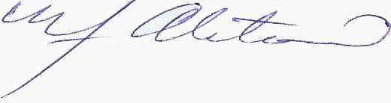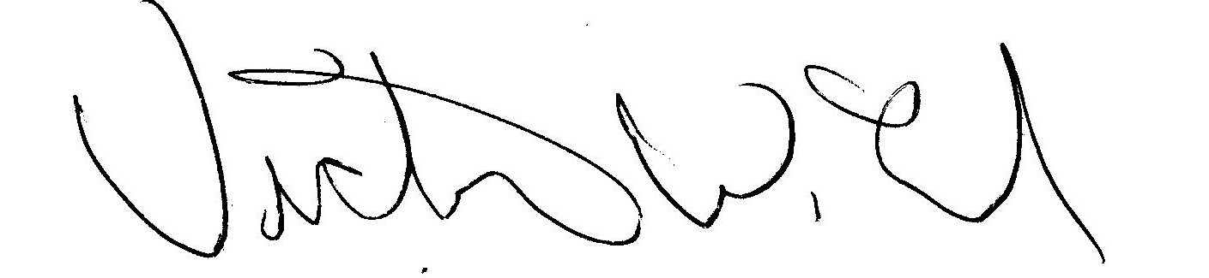
YRDFA Co-Chair/Y-2, Seat 1 YRDFA Co-Chair/Y-6, Seat 2
William Alstrom/Saint Mary’s Victor Lord/Nenana

