P O Box 2898, Palmer Alaska 99645

Tel: 907-272-3141 Fax: 907-272-3142

Resolution: 2019-03

Support the Bering Sea Pollock Fishery conservation of Yukon River Chinook and chum Salmon

WHEREAS the Yukon River Drainage Fisheries Association (YRDFA) works on behalf of subsistence and commercial fishing families within the Alaskan and Canadian Yukon River drainage who depend on wild salmon for subsistence and commercial fisheries; and

WHEREAS Chinook and chum salmon provide an essential source of food, income and culture for the people of the Yukon River, with chum salmon increasingly important for commercial fisheries and subsistence as Chinook salmon decline; and

WHEREAS subsistence harvests of Chinook salmon have been restricted in recent years, and no directed commercial harvests of Chinook salmon have taken place on the Yukon River 2007; and

WHEREAS the mean run size of Canadian-origin Chinook salmon (which comprise approximately 40% of the run) declined 45% for the period 1998-2010 compared to 1982‐1997; and

WHEREAS the Bering Sea pollock fishery has reduced their catch of these same salmon as bycatch; from catching over 122,000 wild Chinook salmon in 2007 and over 700,000 chum salmon in 2005; to passing amendments in 2011 and 2016 to lower bycatch levels to below 30,100 since 2008; and

WHEREAS according to the best available scientific information half to 70% of the Chinook salmon taken as bycatch are of Western Alaska origin, and of this 40% are from the Yukon River; and

WHEREAS in these times of Chinook salmon declines, all sources of mortality must be reduced and all harvesters of salmon must bear equitably in conserving Chinook salmon; and

THEREFORE BE IT RESOLVED that YRDFA thanks the North Pacific Fishery Management Council for their actions to reduce the overall bycatch and implement changes in the fishery to avoid salmon bycatch and we encourage the Council and fishery to take extreme measures to protect Yukon River salmon species.

BE IT FURTHER RESOLVED that YRDFA requests that the North Pacific Fishery Management Council also take action to adopt chum salmon bycatch management measures which will adequately protect Western Alaska chum salmon runs.

COPIES of this resolution will be sent to the North Pacific Fishery Management Council, National Marine Fisheries Service, Alaska Department of Fish and Game Commissioner, Yukon River Panel, U.S. Fish and Wildlife Service, U.S. Department of State, Bering Sea Fishermen’s Association, Association of Village Council Presidents, Tanana Chiefs Conference and other Western Alaska salmon groups.

APPROVED unanimously this 24th day of April 2019 by the Board members and delegates of YRDFA assembled at their Twenty-ninth Annual Meeting held in Fairbanks, Alaska.

Attest:

Thank you. Yukon River Drainage Fisheries Association Co-Chairs:

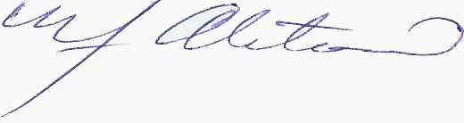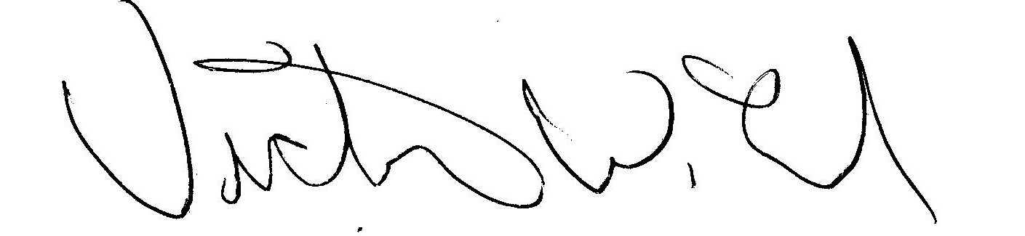
YRDFA Co-Chair/Y-2, Seat 1 YRDFA Co-Chair/Y-6, Seat 2
William Alstrom/Saint Mary’s Victor Lord/Nenana

