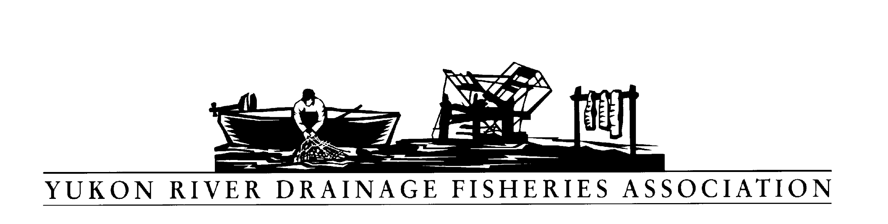
P O Box 2898, Palmer Alaska 99645

Tel: 907-272-3141 Fax: 907-272-3142

Resolution: 2019-02
Opposing the Proposed Road to the Ambler Mining District

WHEREAS, the Yukon River Drainage Fisheries Association (YRDFA) works on behalf of subsistence and commercial fishing families within the Alaskan and Canadian Yukon River drainage who depend on wild salmon for subsistence and commercial fisheries; and

WHEREAS, we have an interest in the preservation of our land, cultures, and people; and

WHEREAS, the 211 mile proposed road will cross 2,900 streams, 11 major rivers, and 1,700 acres of wetland and these waters are habitat for whitefish, sheefish, salmon, pike, burbot, grayling and more; and

WHEREAS, mining activities and practices may threaten the long-term viability of Yukon River wild salmon and other fish stocks by allowing increased pollution and degradation of vital stream habitat; and

WHEREAS, clean water for spawning and rearing is of vital importance for wild salmon and other fish that provide for subsistence and commercial harvest; and

WHEREAS, our Elders have taught us to think beyond the present and measure the effects into the future, for future generations; and

WHEREAS, our subsistence resources guarantee our way of life and culture will continue for future generations; and

WHEREAS, multiple mining companies are staking claims in the Ambler mining district; and

WHEREAS, the State of Alaska seeks to build a private industrial road to the Ambler mining district; and

WHEREAS, mining for mere financial gain poses new threats to the survival of our subsistence resources and our people themselves; and

WHEREAS, those mining companies are exploring for sulfide minerals, which will create acid that will result in toxic heavy metals polluting our lands and waters; and

WHEREAS, building the road may also require using asbestos-laden soil, which could affect our health and the health of our subsistence resources; and

WHEREAS, the road and mine will detrimentally impact water quality and caribou, sheefish, and other subsistence resources that we depend on for our very survival; and

WHEREAS, our Elders have held steadfast against this road development for multiple generations, asserting their inherent rights to subsistence and our way of life; and

WHEREAS, the Tribal Councils of the following sovereign Alaska Native tribes passed resolutions against the proposed Ambler access road; Allakaket, Evansville, Huslia, Kobuk, Koyukuk, Louden, Rampart, Ruby plus the City government of Evansville and the Western Interior Federal Regional Advisory Board.

WHEREAS, a petition submitted to the Bureau of Land Management has 200,000 signatures opposing the Ambler access road, plus the following organizations; and

Alaska Community Action on Toxics Pamela Miller Executive Director Anchorage, Alaska
Alaskans for Wildlife Jim Kowalsky Chair Fairbanks, Alaska
Alaska Rising Tide Brandon Hill Core Collective Member Homer, Alaska
Brooks Range Council John Gaedeke Chairman Brooks Range, Alaska
Center for Biological Diversity Marc Fink Public Lands Legal Director, Senior Attorney Duluth, Minnesota
Cook Inletkeeper Bob Shavelson Inletkeeper & Advocacy Director Homer, Alaska
Earthjustice Rebecca Noblin Staff Attorney Anchorage, Alaska
Friends of Alaska National Wildlife Refuges David C Raskin, Ph.D. President Homer, Alaska
Kachemak Bay Conservation Society Roberta Highland President Homer, Alaska
Mining Action Group of the Upper Peninsula Environmental Coalition Kathleen Heideman Board of Directors Michigan
National Parks Conservation Association Joan Frankevich Program Manager Alaska Regional Office
Northern Alaska Environmental Center Lisa Baraff Program Director Fairbanks, Alaska
Okanogan Highlands Alliance David Kliegman Executive Director Tonasket, Washington
The Ocean Foundation Richard Charter Coastal Coordination Program Washington DC
The Wilderness Society Lois Epstein, P.E. Engineer & Arctic Program Director Anchorage, Alaska
Yukon River Drainage Fisheries Association Wayne Jenkins Director Yukon River, Alaska
Yukon River Inter-Tribal Watershed Council Kelly Donnelly Alaska Executive Director Anchorage, Alaska

WHEREAS, YRDFA is concerned development of the access road and mining operations in tributary and spawning regions may have adverse effects in the Yukon River drainage;

NOW THEREFORE, BE IT RESOLVED that YRDFA opposes the proposed road to the Ambler Mining District;

COPIES of this resolution will be sent to Bureau of Land Management-Central Yukon Region, Alaska Department of Environmental Conservation, Alaska Department of Fish and Game Habitat Division, U.S. Fish and Wildlife refuges in the area, Yukon River representatives and senators.

APPROVED unanimously this 24th day of April 2019 by the Directors of YRDFA assembled at their Twenty-ninth Annual Meeting held in Fairbanks, Alaska.

Attest:

Thank you. Yukon River Drainage Fisheries Association Co-Chairs:

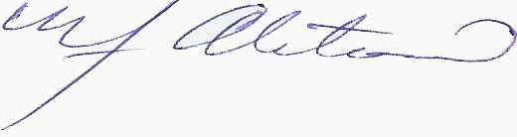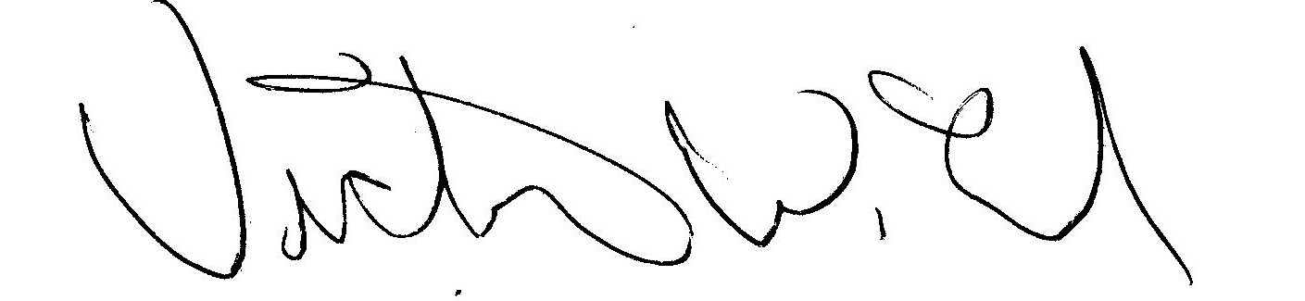
YRDFA Co-Chair/Y-2, Seat 1 YRDFA Co-Chair/Y-6, Seat 2
William Alstrom/Saint Mary’s Victor Lord/Nenana

