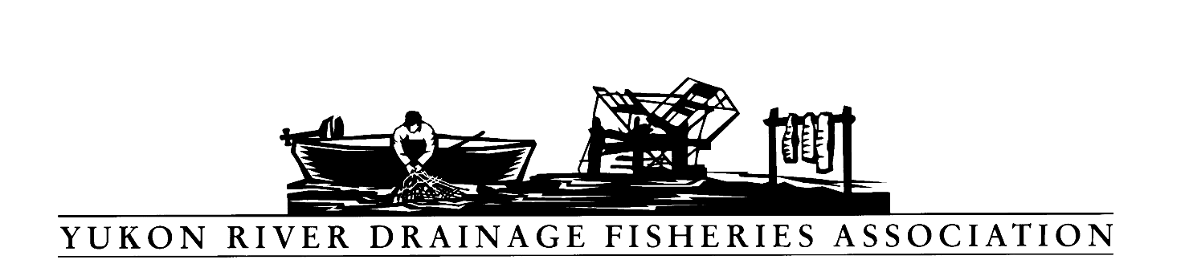
PO Box 2898, Palmer, Alaska 99645
Tel: 907-272-3141 Toll free: 877-999-8566
Fax: 907-272-3142 E-mail: wayne@yukonsalmon.org

Resolution: 2019-01
Escapement to Upper End of Goal for One Full Life Cycle

WHEREAS, the Yukon River Drainage Fisheries Association (YRDFA) works on behalf of subsistence and commercial fishing families within the Alaskan and Canadian Yukon River drainage who depend on wild salmon for subsistence and commercial fisheries; and

WHEREAS, Chinook salmon runs have declined from historical higher levels; and

WHEREAS, due to increased conservation measures, we’ve seen five years of escapement that have met or exceeded the upper range of Canadian escapement goals; and

WHEREAS, the majority of Chinook salmon spawning areas are in Alaska; and

WHEREAS, it is presumed that meeting escapement goals on the Canadian and Alaskan spawning grounds are necessary for rebuilding Chinook salmon runs; and

WHEREAS, Chinook salmon are a critical cultural and nutritional component for Yukon River community health and identify.

THEREFORE, BE IT RESOLVED YRDFA would like to see Yukon River salmon managed so that they continue to meet the upper end of the Canadian and Alaskan escapement goals for one full life cycle going forward.

COPIES of this resolution will be sent to Yukon River Panel members, US Senator Lisa Murkowski, Senator Dan Sullivan and US Representative Don Young, Alaska Commissioner of Fish and Game and Board of Fish, Dr. Phillip Mundy National Marine Fishery Service-AK science center Auke Bay, Alaska.

APPROVED unanimously this 24th day of April 2019 by the Board members and delegates of YRDFA assembled at their Twenty-ninth annual meeting held in Fairbanks, Alaska.

Attest:

Thank you. Yukon River Drainage Fisheries Association Co-Chairs:

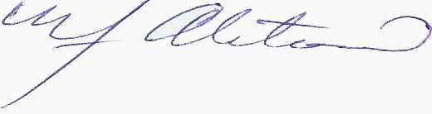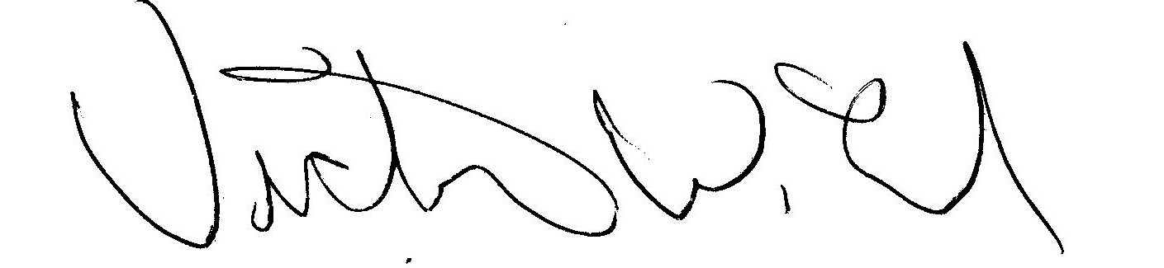
YRDFA Co-Chair/Y-2, Seat 1 YRDFA Co-Chair/Y-6, Seat 2
William Alstrom/Saint Mary’s Victor Lord/Nenana

