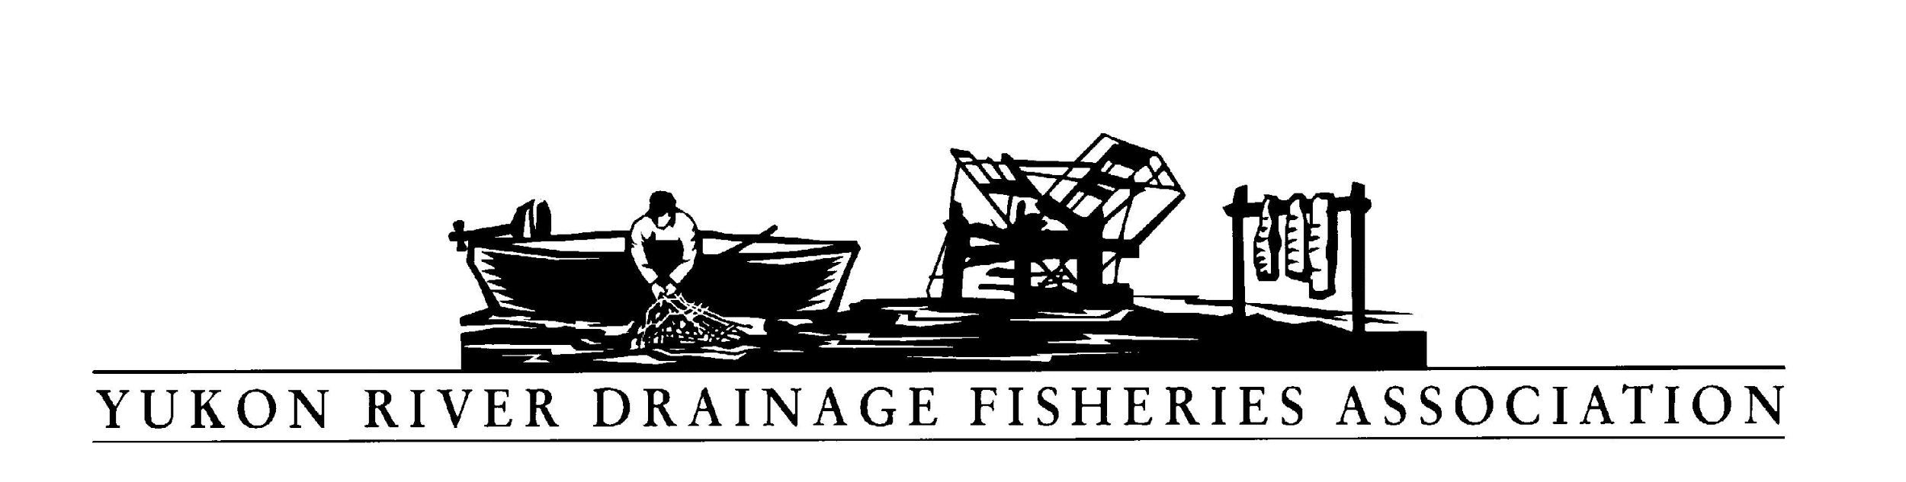

Greetings from the Yukon River Drainage Fisheries Association!

Here is a summary of the 8th Yukon River Salmon In-Season Management Teleconference held this past Tuesday, July 25, 2017. The call lasted 74 minutes.
Estimate of participants: 44

Background: Yukon River salmon management teleconferences are held annually on every Tuesday in June, July, and August for managers and fishers throughout the Yukon River drainage to discuss fishing conditions and management strategies in real time as the salmon run is occurring. Funded by the Dept. of Interior-Office of Subsistence Management.

Media participating: KEAA Eagle community radio, KZPA Fort Yukon radio
Political Representative or staff: Mike Fleagle; Senator Dan Sullivan’s office

Communities participating this week in Alaska: Alakanuk, Marshall, Koyukuk, Huslia, Galena, Ruby, Tanana, Fort Yukon, Eagle, Fairbanks

Coastal District 1-Lower Yukon
Alakanuk: Pam-not much subsistence fishing. Most people going out for commercial fishing and berrying Water very high, a lot have pulled nets out early due to no fish. Waiting for fall chum. Question; do we have the 1st pulse of fall chum? A lot of white fish.

Marshall: Norma-7 households interviewed, none fished, focusing on berry harvest and hoping for better weather. Water steady, up a foot. Salmon looked big and healthy. 130k passed. Not much subsistence activity.

Koyukuk: Ben-windy last 4 days, nobody fishing.
Huslia: Danielle-only 1 of 9 interviewed, fished. Got a few chum and 1 king. Not fishing due to low fish numbers. Orville-lot of people at funeral. Waiting for fall-chum.

Galena: Howard-water-62 degrees. Not much going on, waiting for fall chum.

Tanana: Danielle-no fishing households.
Fort Yukon: Danielle, not many fishing, waiting for fall fish. Andrew, no one fishing, got fish, done. Quality still pretty good. Water up a bit, a bit debris. Taking a break for fall chum.

Eagle:Naomi-most done fishing for the year. Happy with fish caught.
Fairbanks: Reed-on upper Chena, pretty good number of Kings, spawning, some females had white tails. On Nenana, 7/9-10, stronger run then past 6-7 years.

Communities participating this week in Canada

Dawson: Al Vonfinster-river little high, but other local streams are very low; Klondike, Stewart low, Pelly high.

Whitehorse: Jesse-Chinook are at the fish ladder, see on live fish cam. Rain has stopped, finally

Management Reports Agenda:

Jeff/ADFG: in Emmonak-fall season in full swing at the mouth. Off to a good start. Bonnie-fall season research bio. See ADFG weekly update.

Fred/USFW: 47K past Eagle sonar-above avg. 7/19-45% female-13k fish. above avg. All 3 pulses have passed, 4 th passing now. Passed the Canadian escapement mid-point at Eagle. Henshaw/Gissasa, below avg. escapement. Chena and Salcha monitoring hindered by high water.

Holly-comment-TCC included her on a trip to 9 villages in 3 days, incredible opportunity, direct feedback from the people. If you have any questions please call.

Mary Ellen/DFO: plan precautionary approach till we have clear run strength, looking hopeful. Conservative approach for subsistence. Porcupine water very low with high temps but improving. Pelly, several fish camps operating. Yukon Energy-Whitehorse fishcam is picking up some Chinook salmon.

Questions and discussion:
Eric-question from many folks including Kotlik, last week in Y1, test nets showed no fish and yet fisher’s nets were swamped. Still getting kings 12-15 in chum openings. Bright fish. Whats happening with counting? Bonnie-we did not see zero. Jeff-we have had this before. Been trying to get deeper, rough weather made it a bit tough. 3 years ago we missed a massive wall of fall chum. 12-13 hr. period. Sometime pulses are so packed we may miss them. We are addressing it. B-Kings still being caught. E-we are doing a lot more subsistence on kings. What was the reason for not selling kings. Y2 guys need money, $100/fish. J-prohibition of sales in regulation, BOF not clear. E-we checked with attorney general-said you have authority. Why not? J-we looked at it. E-why does management open it up? J-went to commissioner, E-wish you guys would reconsider. H-$100/lb. ? E-huge chum market and getting underpaid so looking at alternate markets. Worse situation. H-challenging year for Y2. Hope a market can be improved for next year. J-there is a commercial coming. Norma-having a hard time, not just Y2-firefighting-none have gone out-other communities are hurting too. Since early in fall chum and samples could be sent to other buyers, might be interested our fish.

Ben-What latest passage of fall chum at Pilot Station and when is opening in 4a? Jeff-207K passed sonar. 12:01am 8/3. 5 days a week starting tonight 6pm.

Arnold in Nulato-what on august 3? Jeff- sub-district 4A onto regulatory schedule.

Jesse-announces 2017 EdEx one or two more slots open.

Don- Fred mentioned the escapement were below average, they seem to be considerably below. Do F or H have any explanation? The only ones below right now at the Henshaw and Gisasa. D-Andy also seems strange with the big run? H-great question, looking at Eagle at midway, we have a bit more time. Also need to look at harvest and post fishing info. We have a harvest study, can look at genetics and will be compiling and sharing. D-thanks

Natasha-maybe half way through? Run a week early-what indicates that? H-Fred? Not a week early, a little early to normal. Especially low water. Fred-at pilot 2016 tracked almost identical-between the 20-24th.

Martin-let folks know our Y2 commercial time to get that process started for a fishery disaster. Need to get that process started. Hurting down here. Families are struggling. J-reiterate, stand by for an announcement.

Edna-Boreal-still working on something for Y2. Many thank Edna.

James Y1-wondering about sales of King salmon, majority has passed by. Jeff-no king period this year. We had one period in Y1 where sales of incidentally caught were allowed. Prohibition will remain in place rest of the year. James-What about the boundaries, J-They have not changed. Can fax a map-James-are they going to open up a King season? Why not one early in the season- H-We have regulations that have forced subsistence restrictions, but saw a good return, have had many years. Regs make it pretty clear no sale of kings. Need more clarity from Board of Fish. We need a large enough run to allow commercial harvest. J-To be clear, there has not been a 2017 King salmon directed fishery.

For further information, please contact the Yukon River Drainage Fisheries Association at 907-272-3131 or look for us on the web at www.yukonsalmon.org.
For Alaskan management information, please visit:
http://www.adfg.alaska.gov/index.cfm?adfg=fishingCommercialByArea.interior
or call toll-free 1-866-479-7387 for recorded fishing schedules and assessment information.

For Department of Fisheries and Oceans, Canada updates, please visit:
http://www.pac.dfo-mpo.gc.ca/yukon/fmcountingfac.htm

Please join us on the next teleconference, Tuesday at 1 p.m. Alaska time (2 p.m. Yukon time). As a reminder, the toll free number is 1-800-315-6338 and the code is YUKON# (98566#).

Thanks for your interest and participation.
YRDFA Board and staff

